YSGOL BRO CYNLLAITH
Containment (Lockdown) Policy
September 2021

As part of our Health and Safety policies and procedures the school has a Containment (Lock Down) Policy.
On very rare occasions it may be necessary to seal off the school so that it cannot be entered from the outside. This will ensure that pupils, staff and visitors are safe in situations where there is a hazard in the school grounds or outside the school in the near vicinity.
A lockdown is implemented when there are serious security risks for the premises due to, for example, nearby chemical spillage, proximity of dangerous dogs, serious weather conditions, a reported incident/civil disturbance in the community or attempted access by unauthorised persons intent in causing harm/damage.

Notification of Full Lockdown
Staff will be notified that lock down procedures are to take place immediately on hearing X5 3 second bursts of the school bell.

Procedures:
Follow the CLOSE procedure:
Close all windows and doors
Lock up
Out of sight and minimise movement
Stay silent and avoid drawing attention
Endure. Be aware you may be in lock down for some time

1. The above signal will activate a process of children being ushered into the school building as quickly as possible and the locking of the school’s classrooms, offices, connecting doors and all outside doors/ shutters where it is possible to remain safe.
2. At the given signal the children remain in the room they are in and the staff will ensure the windows and doors are closed/locked and screened where possible and children are positioned away from possible sightlines from external windows/doors. Lights, Smart boards and computer monitors to be turned off. Mobile phones are put on silent mode.
3. Children or staff not in class for any reason will proceed to their classroom as quickly as possible.

NO ONE SHOULD MOVE ABOUT THE SCHOOL

4. Staff to support children in keeping calm and quiet.
5. Staff to remain in lock down positions until informed by key staff e.g. Senior Leadership Team or Office Staff in person that there is an all clear.
6. As soon as possible after the lock down teachers return to their classrooms and conduct a register and notify the headteacher immediately of any pupils not accounted for.

Staff Roles:
1. School administrator to ensure that her office is locked and police called if necessary.
2. Head locks the school’s front doors and entrances.
3. Individual teachers/ TAs lock/close classroom door(s) and windows. Nearest adult to check exit doors.

Communication with parents:
If necessary parents will be notified as soon as it is practical to do so via the school’s established communication network – school app/text message
Parents will be told: ‘The school is in a full lockdown situation. During this period the phone and entrances will be unmanned, external doors locked and nobody allowed in or out.’ Depending on the type and severity of the incident, parents may be asked NOT to collect their children from school as it may put them and their child at risk. Pupils will not be released to parents during a lock down. Parents will be asked not to call school as this may tie up emergency lines. If the end of the day is extended due to the lock down, parents will be notified and will receive information about the time and place pupils can be picked up from office staff or emergency services.
A letter to parents will be sent home on the nearest possible day following any serious incident to inform parents of context of lockdown and to encourage parents to reinforce with their children the importance of following procedures in these very rare circumstances.

Partial Lockdown
This may be as a result of a reported incident / civil disturbance in the local community with the potential to pose a risk to staff and pupils in the school. It may also be as a result of a warning being received regarding the risk of air pollution, etc.

Notification of Partial Lock down
Alert to staff: ‘Partial lockdown’
All outside activity to cease immediately, pupils and staff return to building.
All staff and pupils remain in building and external doors and windows locked.
Movement may be permitted within the building dependent upon circumstances but this must be supervised by a member of staff. All situations are different; once all staff and pupils are safely inside, senior staff will conduct an ongoing and dynamic risk assessment based on advice from the appropriate body e.g., Emergency Services, Local Authority. This can then be communicated to staff and pupils.
‘Partial lockdown’ is a precautionary measure but puts the school in a state of readiness (whilst retaining a degree of normality) should the situation escalate.

Lock down drills
Lock down practices will take place at least once a year to ensure everyone knows exactly what to do in such a situation. Monitoring of practices will take place and staff debriefed for positive reinforcement or to identify required improvements.
Review: This policy and procedures will be reviewed annually as a part of the School’s Health and Safety procedures

Adopted by the Governing Body of Ysgol Bro Cynllaith on : 25th November, 2021

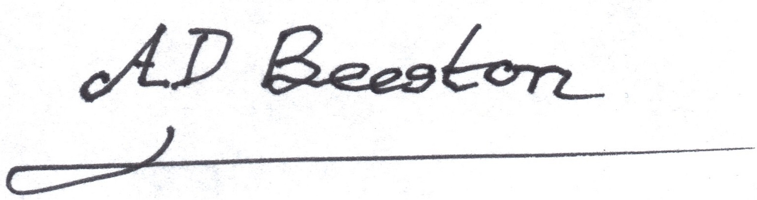
Signed by the Chair of Governors :

