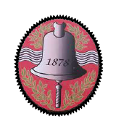  15th May 2023 | Ysgol Bro Cynllaith  Llansilin, Oswestry, Shropshire/Powys  SY10 7QB  Tel: 01691 791365  Email: office@cynllaith.powys.sch.uk  Headteacher: Mrs Rhian Mair Jones  BA (Hons), NPQH | 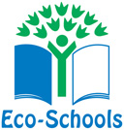 | 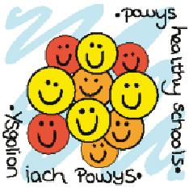

Dear Parent/Carer
For the rest of this half term, we will be discussing the NSPCC’s Underwear Rule as part of our Health and Wellbeing Area of Learning.
During these discussions we will aim to teach pupils the following important safety skills without giving explicit information or telling scary stories.
We will be teaching pupils the NSPCC’s Underwear Rule, using the ‘PANTS’ acrostic, which is like a green cross code for staying safe from sexual abuse.
PANTS stands for:
Privates are private.
Always remember your body belongs to you.
No means no
Talk about secrets that upset you.
Speak up, someone can help.

The lessons will introduce a range of ideas, all delivered in a way that’s fully age appropriate. These include:
- “appropriate” and “inappropriate” touching.
- your child’s right to say no to things that make them feel upset or uncomfortable.
- naming parts of the body
- who your child can turn to if they ever feel upset or worried.

If you would like to know more about the NSPCC’s campaign and see how you can help keep your children safe in partnership with your child’s school, more information can be found at http://www.nspcc.org.uk/preventing-abuse/keeping-children-safe/underwear-rule/

