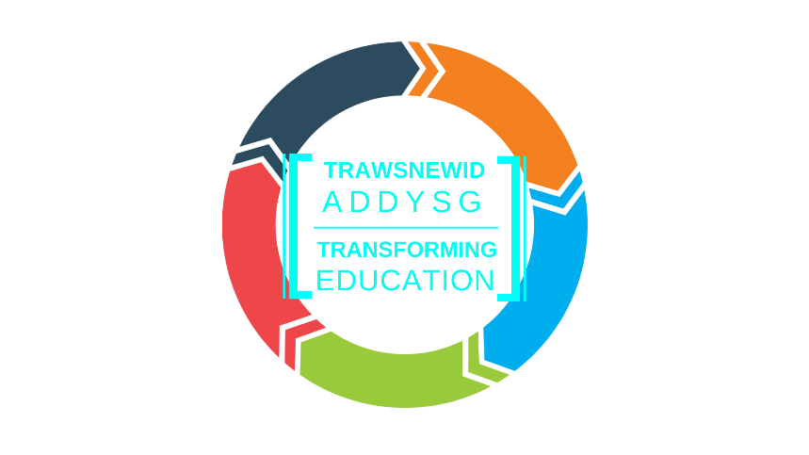

Transforming Education Programme in the Llanfyllin/North Welshpool catchment area
Progress Report
March 2021
As you know, the Council’s Cabinet approved a Programme Business Case for capital investment in the Llanfyllin/North Welshpool catchment area last September which indicated a ‘preferred way forward’ for the area. Further detailed assessment of all options is now required in order to develop proposals and plans that can be formally consulted upon. We are taking the Programme forward on a phased basis as shown below:
- The first phase of the Programme is the development and consideration of options for Llangedwyn CIW Primary School and Llanfechain CIW Primary School, along with plans for capital investment in Llansantffraid CIW Primary School. This phase is currently underway.

- The second phase of the Programme will be the development and consideration of options for Ysgol Bro Cynllaith, Ysgol Gynradd Pennant and Ysgol Gynradd Llanrhaeadr-ym-Mochnant. It is expected that this exercise will be completed shortly after Easter 2021.
- The third phase will involve the development and consideration of options for Llandysilio CiW Primary School, Carreghofa CP School, Arddleen CP School and Brynhafren CP School. This will start in the autumn term 2021.

- The Programme Business Case also included the development of an all-age community campus in Llanfyllin. We hope to be in a position that we can commission the initial feasibility work towards the end of this year.
We will be providing you with regular progress reports to ensure that you are all kept informed and please be assured that we will be working closely with all stakeholders as the Programme develops.
Regards
Transforming Education Team
Powys County Council

