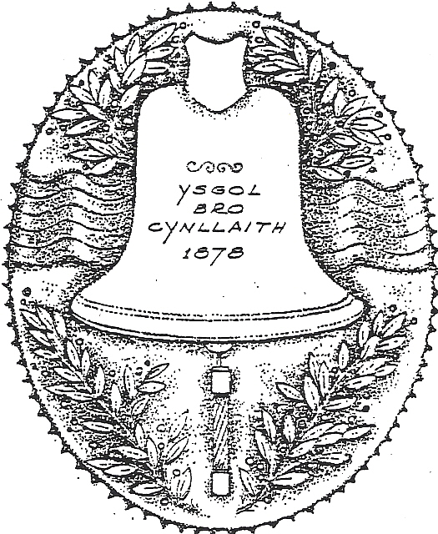 | Ysgol Bro Cynllaith  Llansilin, Oswestry, Shropshire/Powys  SY10 7QB  Tel: 01691 791365  Email: office@cynllaith.powys.sch.uk  Headteacher: Mrs Rhian Jones |  | 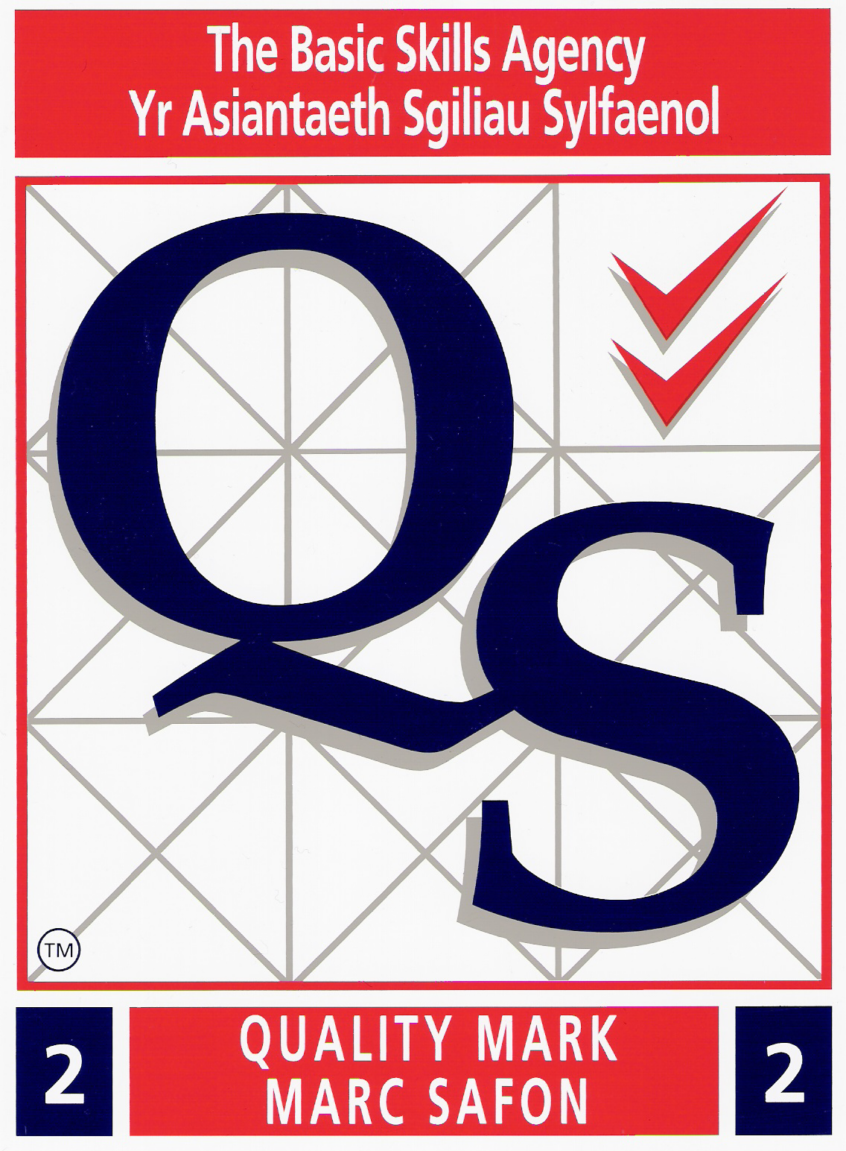

IMPORTANT

10th July 2020

Dear Parents

DEBT – PARENTPAY

With just 2 weeks left until the end of term I would be grateful if you could please log into your ParentPay account and settle any debts that are still outstanding. In particular these would relate to School Meals, Breakfast Club, Swimming and After School Club.

If you are unsure of anything or are having any problems then please do not hesitate to contact the office on either of the contact details at the head of this letter.

Thank you in advance for your co-operation and support.

With regards,

Lesley Edwards
School Secretary

