Home learning/Gwaith cartref

Hello again everyone,

We are now beginning the final half term of your school year. I hope you have had a break from the computer over the holiday and are continuing to keeping yourselves safe and well.
Well done and thankyou to everyone who is persevering with the home learning tasks. I know that it is very difficult to keep motivated but keep going, you are doing an excellent job.
Remember, please do not worry if you can’t do some of the tasks, all that we ask is that you have a go and try your best.

Here is the next home learning plan, which has lots of new activities for you to try – just click on the links.

REMEMBER – I am available on our Microsoft Teams site to answer any questions you have and to help you with anything.

Maths Tasks | English Tasks
- Play on j2blast HWB.  - Do one of the 5-a-day challenges on Corbett maths. Look for the date you are on and click on;  Bronze for Year 3  Silver for Year 4  Gold for Year 5  Platinum for Year 6  - Watch one of the daily maths lessons on BBC Bitesize and complete the activities  dailylessons  Carol Vorderman – Free online maths school  https://www.themathsfactor.com/  Maths Challenge Mats 1-10 – these are the mats we use in school. They are in Welsh and English. Have a go at some of them! | - Continue to read your books.  - Practise your spellings on j2 Spell Blast  - Watch one of the daily English lessons on BBC Bitesize and complete the activities. dailylessons  - Create a character  - Free book by Dan Freedman  - Lively videos to help you with your spelling https://www.sirlinkalot.org/  - Create the cover of a book you would really love to read

On the BBC daily lessons site, there are also all the other curriculum subjects.
Click on the schedule below for next week. Take a look and see what you might like to try;

Weekly schedule

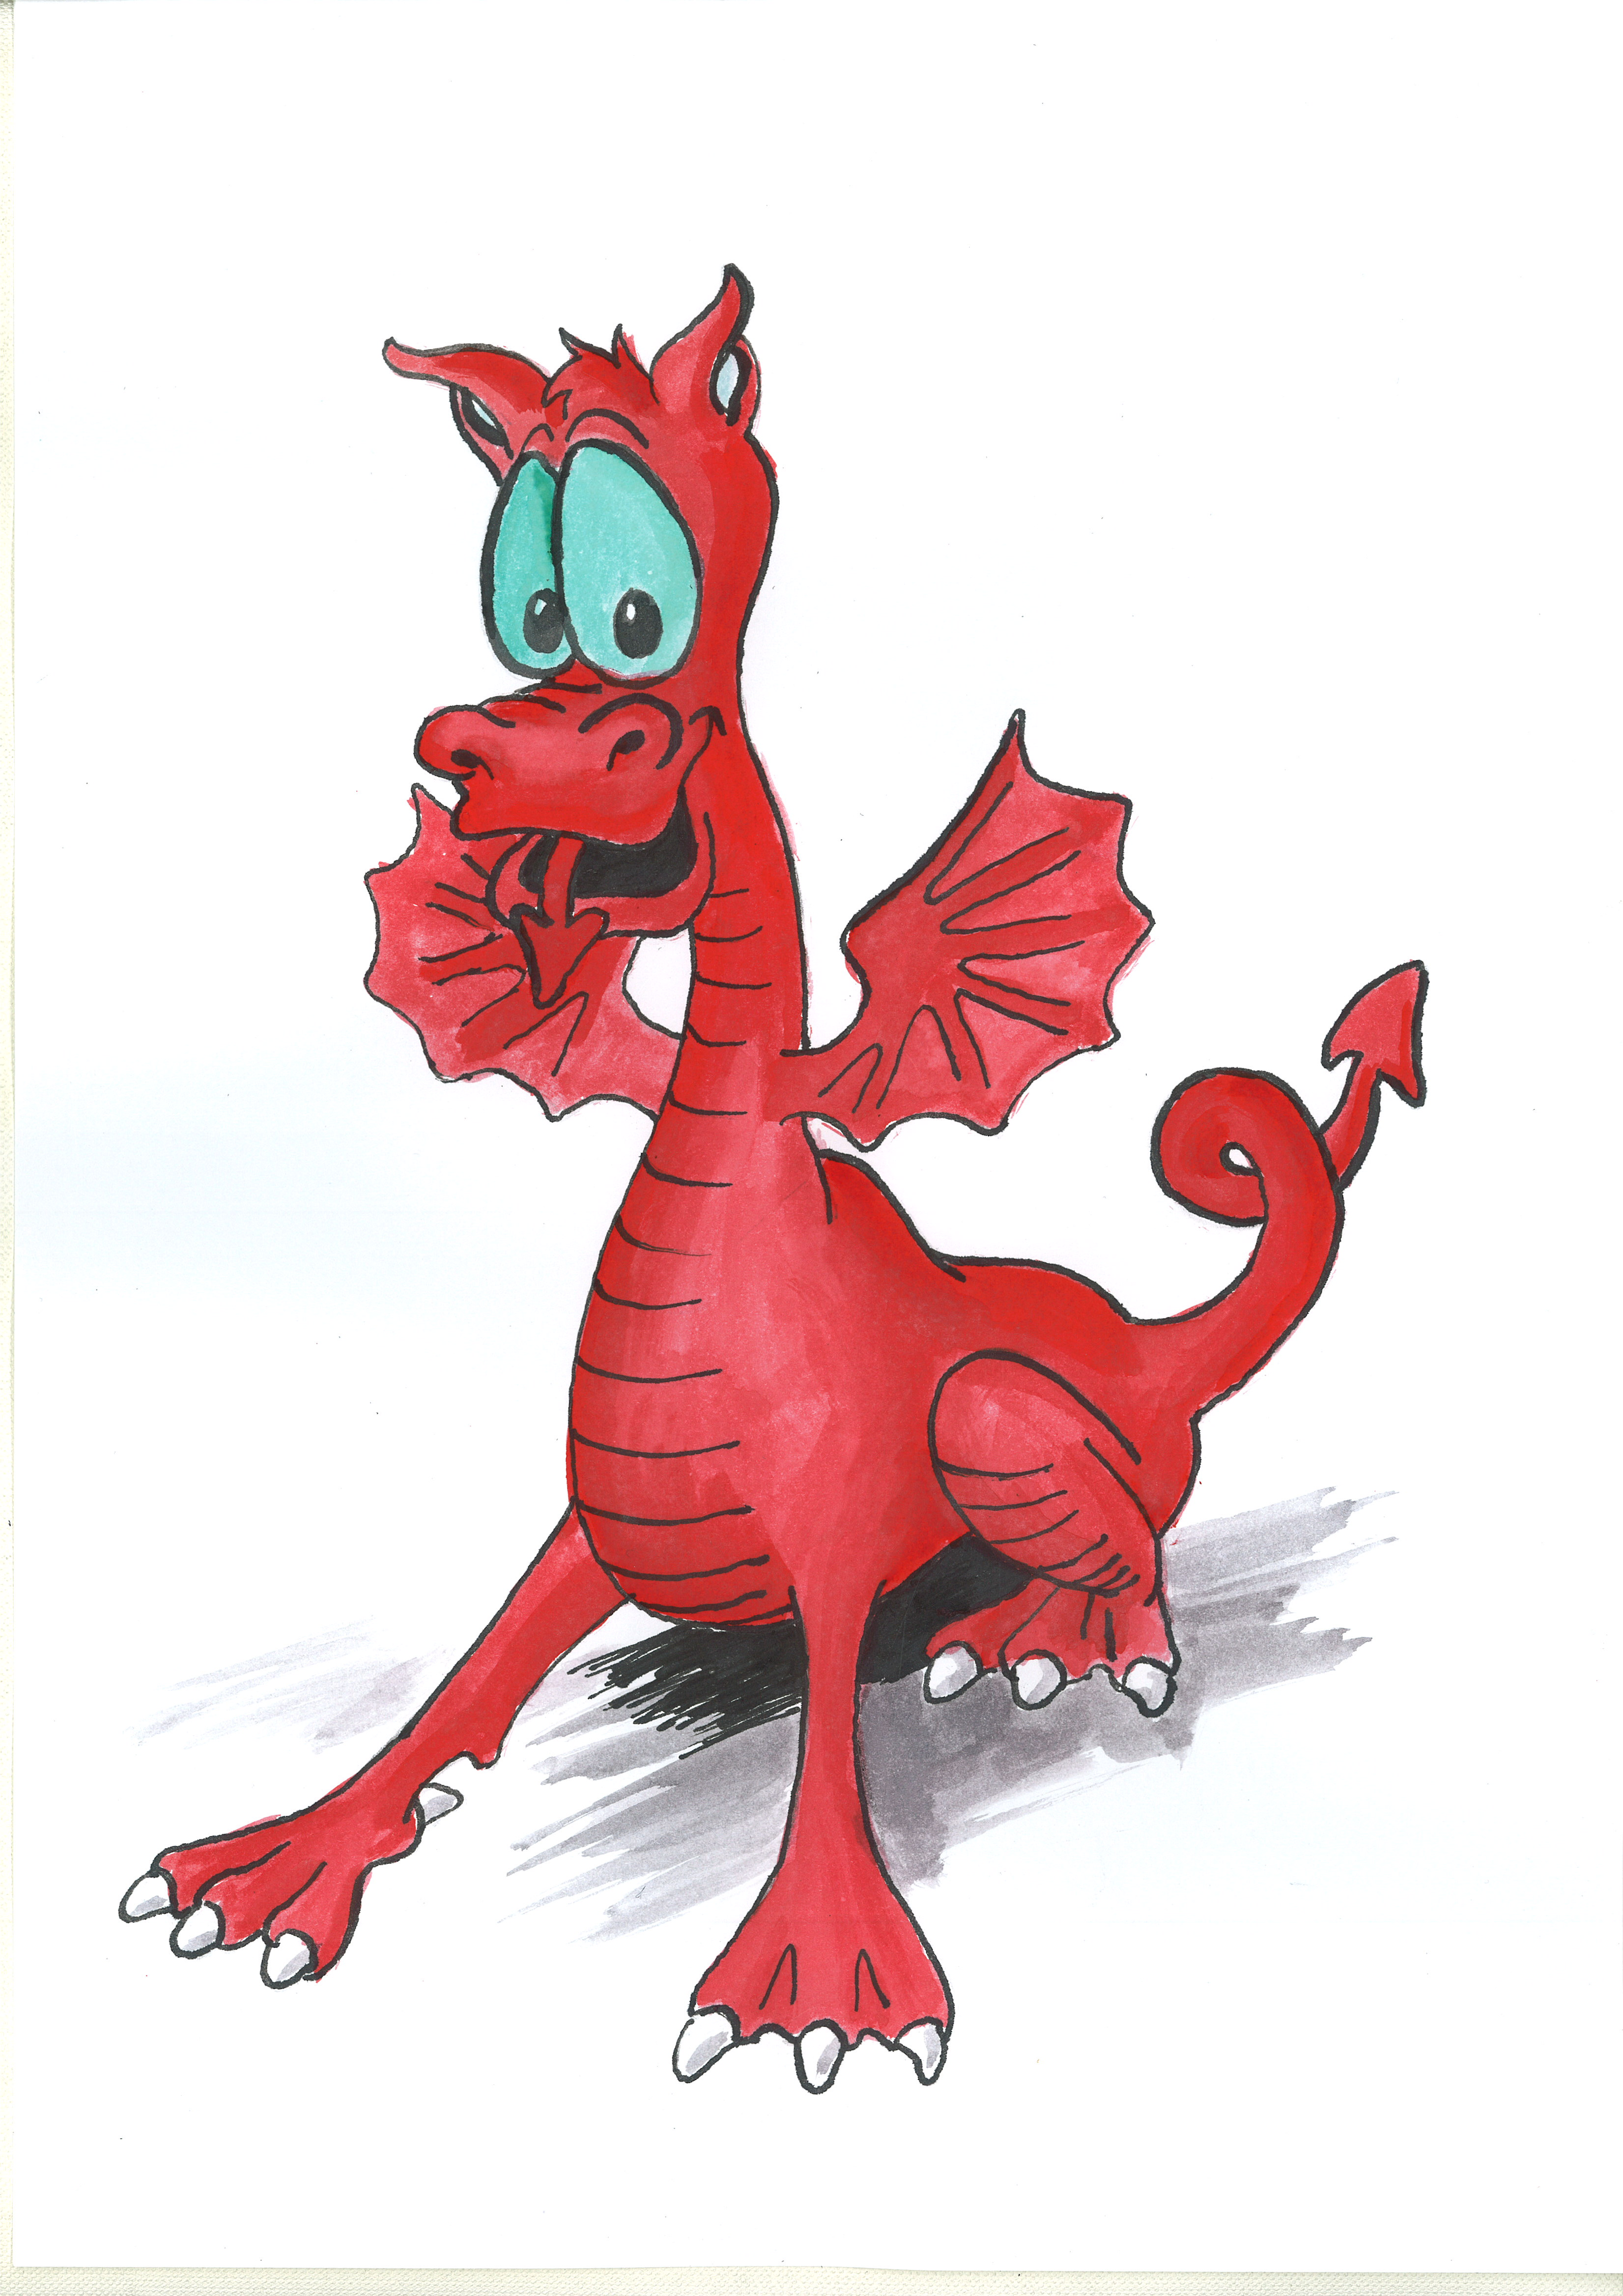

Welsh/Cymraeg

Year 5/6
Year 3/4

Activity 5
Activity 6

Activity 5
Activity 6

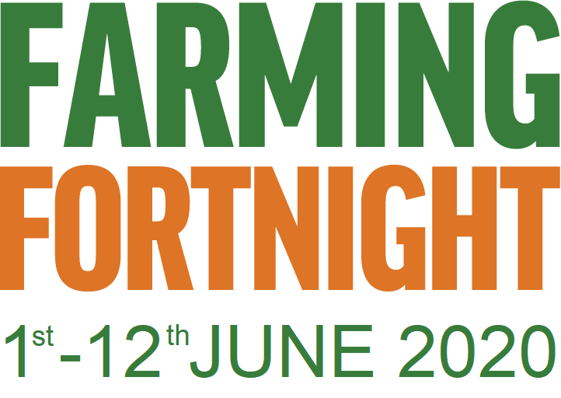

Click -FARMING FORTNIGHT for lots of video clips of different farmers talking about their work and also activities for you to do.

Week 1:
- Introduction to the British Countryside and food production #MarketMonday
- Arable - wheat and oats #TractorTuesday
- Sheep #WoollyWednesday
- Pigs #Oink
- Chickens (poultry) #FeatheredFriday

Week 2:
- Cows – beef and dairy #MooingMonday
- Fruit and Vegetable production #TastyTuesday
- Woodland #WellyWednesday
- Jobs/careers #FutureFarming
- Programme summary to recap on what has been learnt #FarmingFriday
Topic - Spring/Summer
Let’s Wonder: JUNGLE HABITATS

Mon 1st June - MON, 1st JUNE: Amazing Amazon
Take on the role of an intrepid Amazon explorer and discover the different layers of the rainforest and the fascinating animals that live there. Then create your own non-fiction book about the rainforest and why we need to protect it.
Jungle activities
Jungle worksheet

Create your own non-fiction book

TUES, 2ND JUNE @ 11AM: Go on a garden safari
Join Matt for a Facebook Live event as he looks at some of forests most fascinating insects; ants. He'll share some tips on how to find, them record them, and study their incredible activities.
WED, 3RD JUNE @ 11AM: Make it - Trillion Trees Art Challenge
Create an artwork inspired by the rainforest. Be inventive; you might want to make an illustrated poem, a paper cut out, a painting or a journal of everything you’ve used that has come from the rainforest.
Art Challenge

- Be Active:
https://www.nhs.uk/10-minute-shake-up/shake-ups

https://www.bbc.co.uk/teach/supermovers

Recommendation at least 2 hours of exercise a week.

Additional learning resources your parents may wish to have a look at.
Classroom Secrets Learning Packs - These packs are split into different year groups and include activities linked to reading, writing, maths and practical ideas you can do around the home.

Twinkl - to access these resources click on the link and sign up using your own email address and creating your own password. Use the offer code UKTWINKLHELPS.

