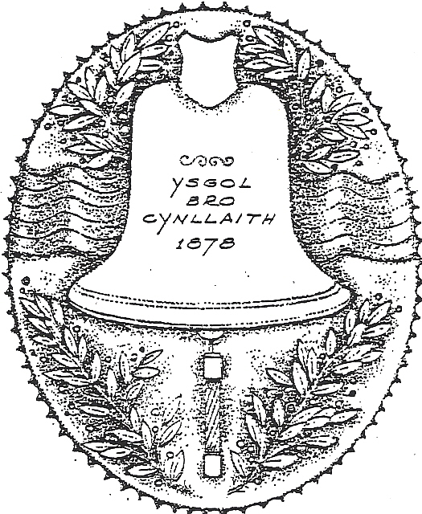 | Ysgol Bro Cynllaith  Llansilin, Oswestry, Shropshire/Powys  SY10 7QB  Tel: 01691 791365  Email: office@cynllaith.powys.sch.uk  Headteacher: Mrs Rhian Jones |  | 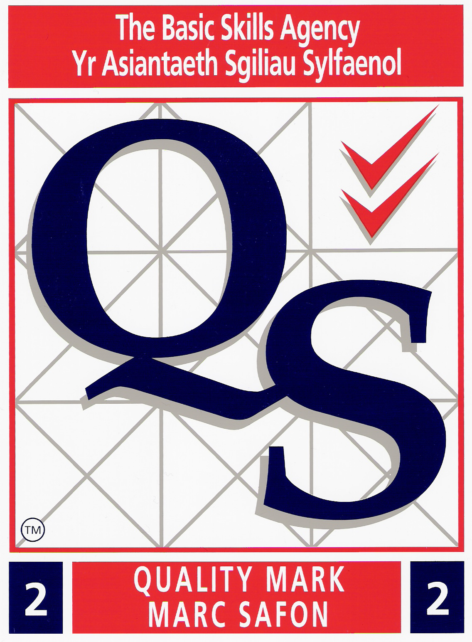

10th January 2020

Dear Parents

SWIMMING BUS CONTRIBUTIONS

Just to remind parents that Swimming Lessons will begin again on Monday morning 13th January at Oswestry Leisure Centre. Could you please make sure your child brings their swimming bags to school with them. We will be swimming every Monday morning through to July.

The cost of the bus will remain at £3 per child per session, but you will not be charged if your child is absent.

There are a total of 11 sessions in the Spring term and 11 sessions in the Summer term. The contributions will be collected via Parentpay so could we please ask that you make your payments either weekly or half termly or termly. As the payment item has been set up differently this year, we will not be checking your child off on a register so you will not be alerted to a ‘debt’.
Any credits that have already been made, or were remaining in your swimming account have been refunded.

If you have any queries regarding this please do not hesitate to contact the school office.

With regards,

Lesley Edwards
School Secretary

