The school began the Cymraeg Campus language charter in December 2016. Baseline data from the questionnaire showed that pupils thought that learning Welsh was important and that they enjoyed learning Welsh. The areas in need of development were, the use of Welsh apps, the use of Welsh outside of the classroom and Welsh reading. Led by an effective Welsh coordinator, the school has now identified and implemented appropriate practices to complete the success criteria.

Pupils are now encouraged to use Welsh both inside and outside the school building which contributes to the school’s Welsh ethos. The use of ‘Cymraeg ar dy Dafod’ has enhanced the pupils use of Welsh inside the classroom. The weekly Welsh assembly, the ‘Wal Graffiti’, the Welsh mascot initiative, yard games and ‘Patrwm yr Wythnos’ have enhanced the use of Welsh outside the classroom. The ‘Criw Cymraeg’ introduce ‘Patrwm yr Wythnos’ during the Welsh assembly and this is practiced during the week. Pupils were able to recall a number of recent phrases including ‘Beth wyt ti’n ddarllen?’, Faint yw dy oed di?’ and ‘Ble rwyt ti’n byw?’ The Welsh mascot initiative has also been developed successful in both key stages and pupils are proud to show off their work.

The school now ensures that they organize a range of enrichment activities to develop pupils’ Welsh language skills. Ysgol Bro Cynllaith has celebrated St David’s day and ‘Santes Dwynwen’ day, held an Eisteddfod, organized a Welsh trip to the Urdd Centre in Cardiff and visited the Hedd Wyn Heritage Centre in Trawsfynydd as well as the Mari Jones Heritage Centre in Bala. During the Spring term, pupils will also be attending the Urdd camp in Llangrannog. Pupils have learned the Welsh National anthem and they regularly sing Welsh songs during assemblies and services. Many of the pupils are Urdd members and they regularly participate in the sport competitions. Welsh is prominent during community services, e.g. in their rememberance service, pupils recited Hedd Wyn’s poem, ‘Rhyfel’ in Welsh. The school also invited the ‘Ti a Fi’ group to the school and pupils organized a range of Welsh activities for the younger children to enjoy. All of these activities and initiatives have had a positive effect on raising the profile of ‘Cymraeg’ at Ysgol Bro Cynllaith. The coordinator noted that, ‘Parents were reporting that pupils in the Foundation Phase especially are speaking Welsh at home and trying to teach them’ and consequently, ‘Parents are taking up Welsh classes to help their children at home’.

The school now makes regular use of a range of Welsh apps and the ‘Criw Cymraeg’ have prepared posters advertising them to the rest of the school. Ks2 pupils named ‘Guto Nyth Bran’ as their favourite app whilst pupils in the foundation phase named ‘Betsan a Rocco yn y Pentre’ as their favourite. Pupils in both key stages now have regular opportunities to develop and practice their reading skills. There is a range of Welsh books available in both classrooms and pupils keep individual reading records of the books read. Nearly all pupils could name books which they had read; these included books from the ‘Nici a Cris’ and ‘Pip’ series as well as the ‘Bore Da‘ magazine. Fp pupils stated that they enjoyed the ‘Tric a Chlic’ and ‘Fflic a Fflac’ books.

The use of Welsh across the Curriculum is beginning to develop. For example, ks2 have completed written work about ‘Fy Arwr’, Mari Jones and Hedd Wyn. The foundation phase have completed data work in Welsh about animals and colours on HWB. However, this an area in need of further development.

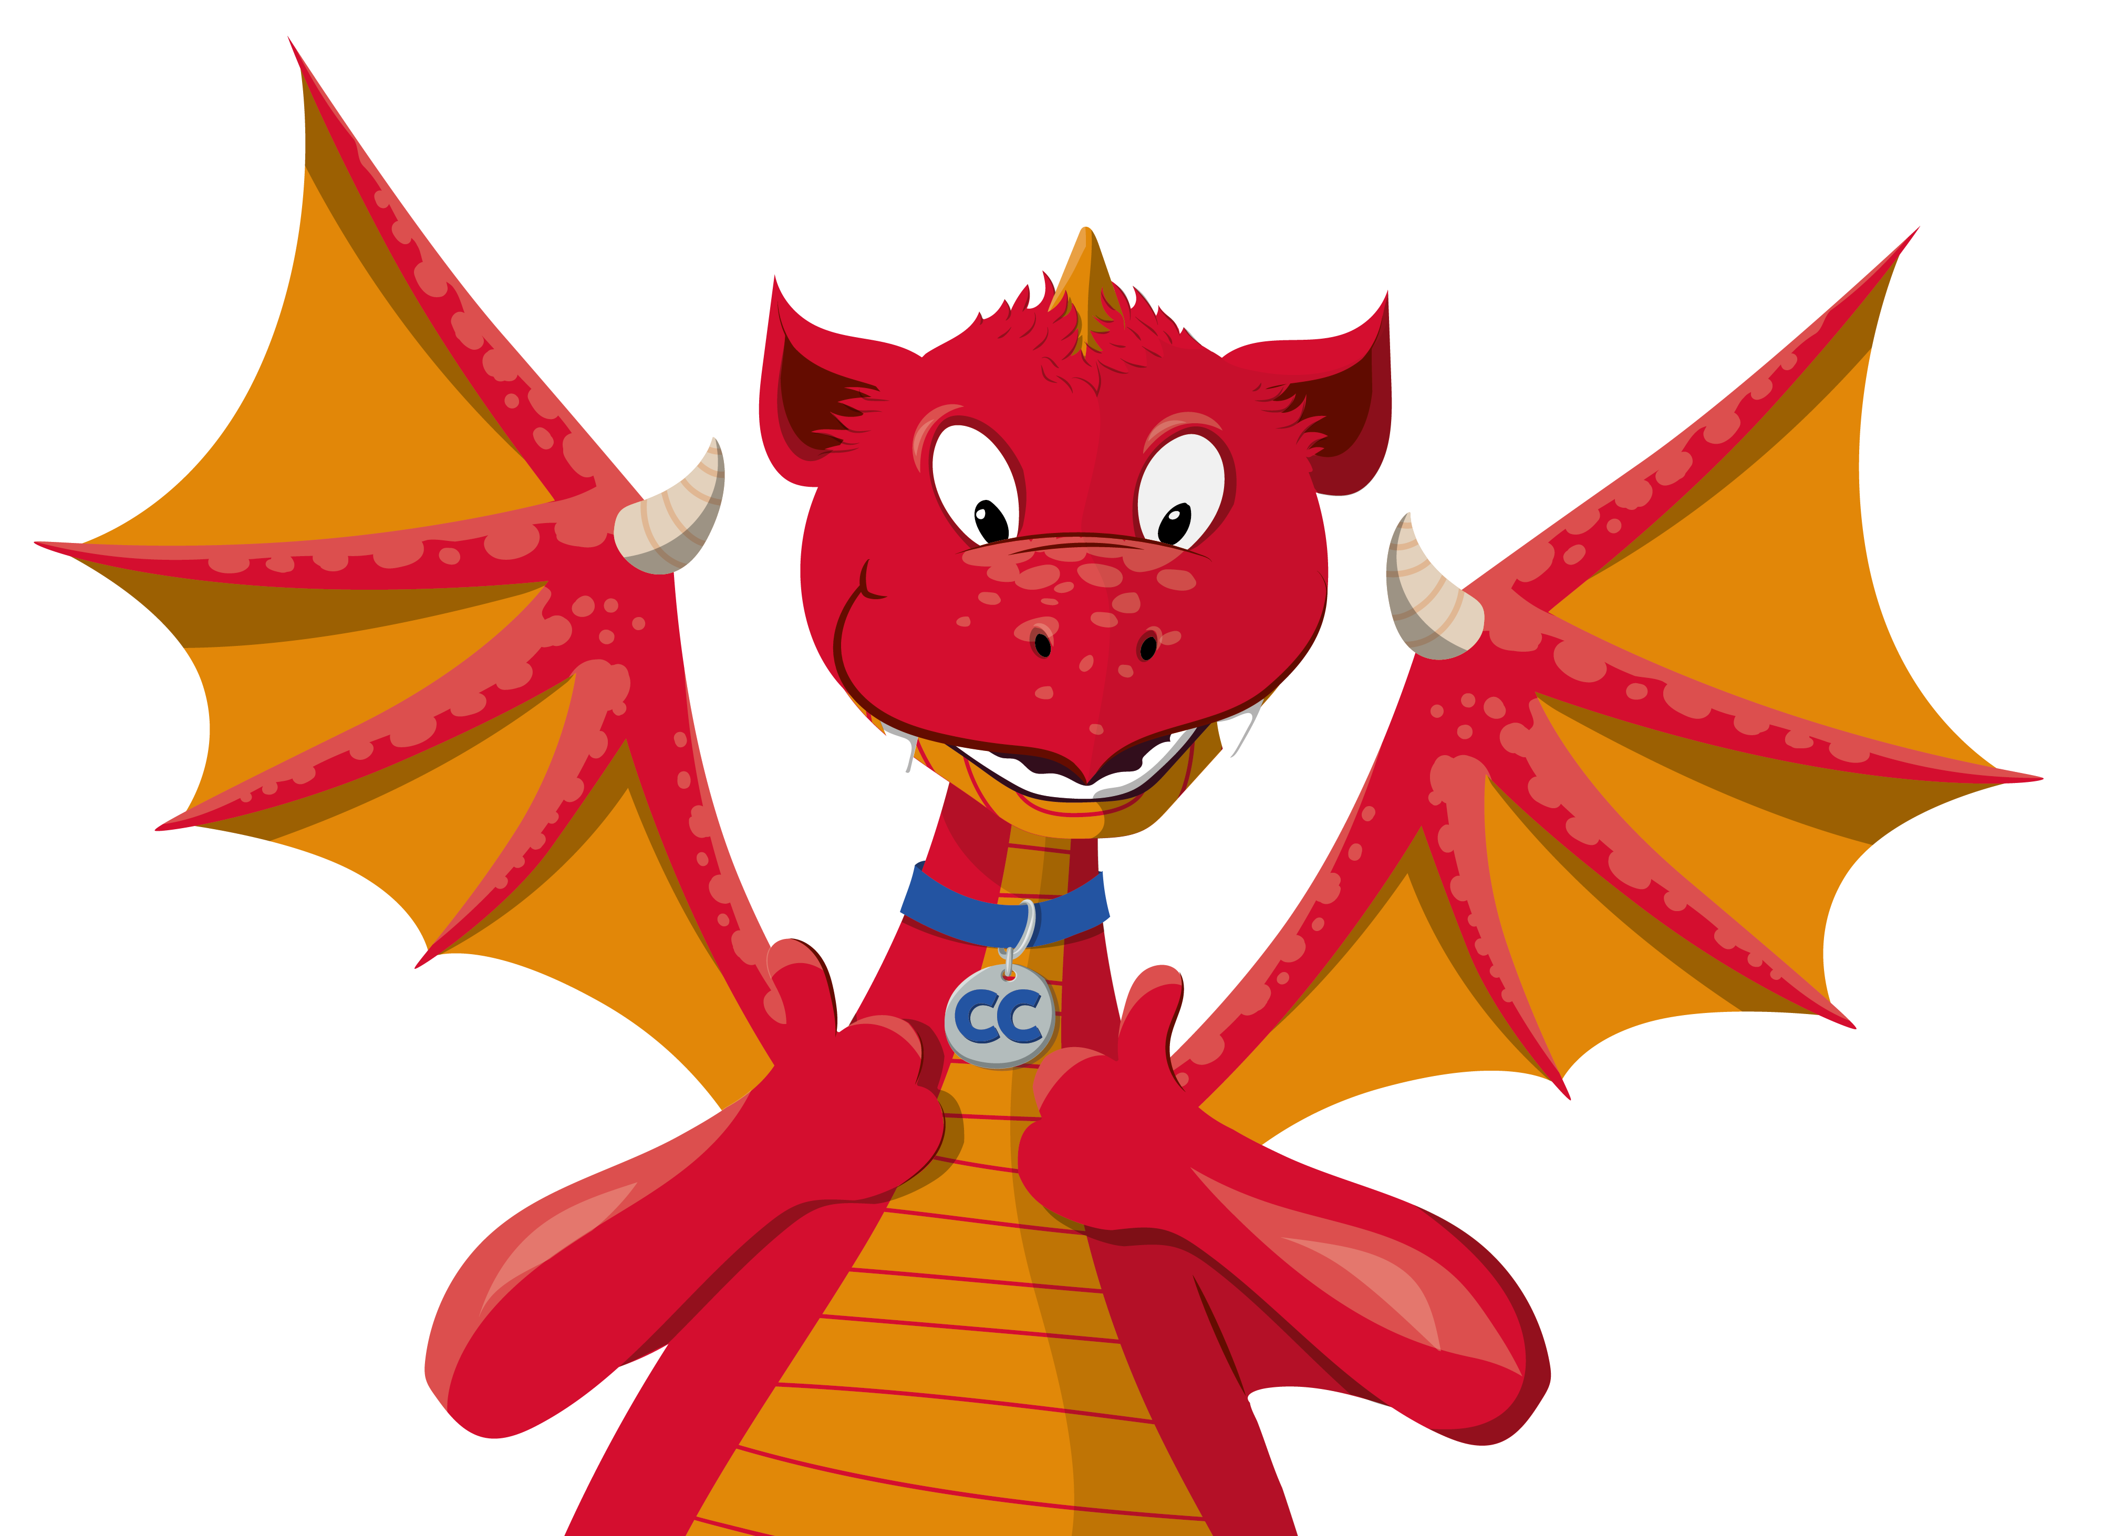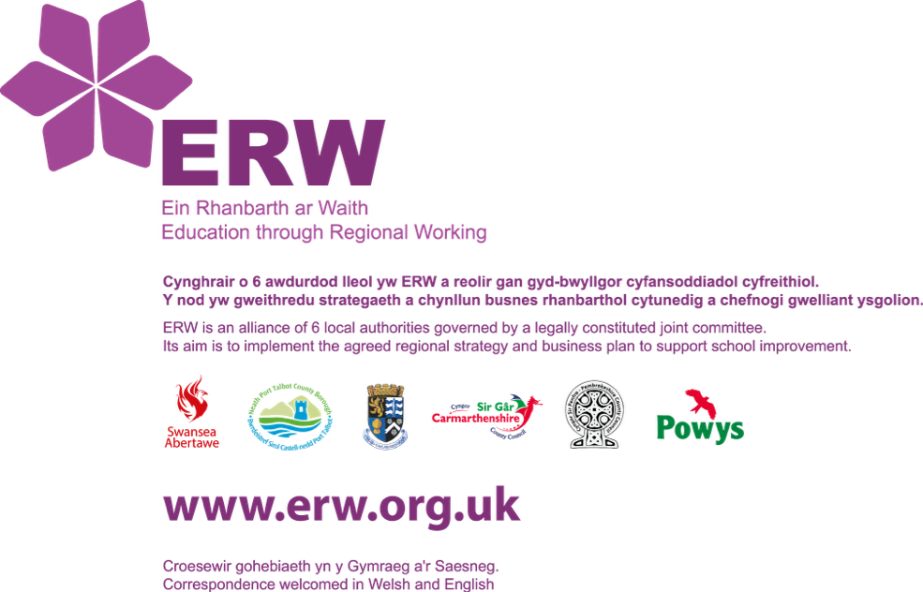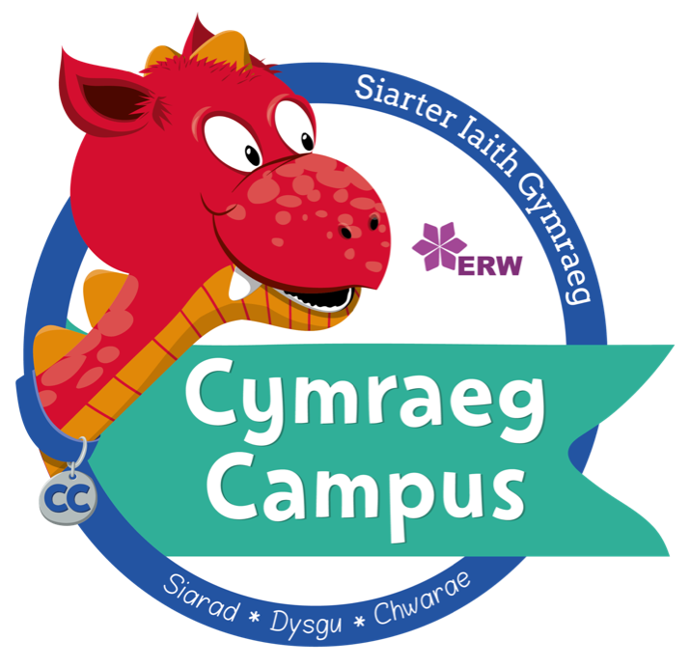

|  |  |
| --- | --- |
| Ysgol / School | BRO CYNLLAITH |
| Dyddiad / Date | 03.12.18 |
| Swyddog / Officer | Gwenan Hughes |

ADRODDIAD GWOBR EFYDD

SIARTER IAITH CYMRAEG CAMPUS

@CymraegCampus

The school has an active ‘Criw Cymraeg’ who have successfully raised the profile of the Welsh language throughout the school. The ‘Criw’ work diligently to implement initiatives and promote the use of Welsh inside and outside the classroom. The ‘Criw’ are proud of their role, they display positive attitudes towards the language and culture of Wales and they clearly understand the advantages of being able to speak Welsh. There is a display in the corridor which promotes positive attitudes towards the Welsh language and culture of Wales. Pupils’ Welsh work is also displayed effectively on a range of displays outside the classroom. The ‘Criw Cymraeg’ take responsibility for introducing the phrase of the week and distributing rewards. The school has introduced a reward system for speaking Welsh, i.e. pupils collect gold stars and are awarded with a certificate if they successfully complete their chart. The ‘Criw’ have also conducted a wall trawl to assess whether sufficient Welsh is visible on class displays.

The Welsh language has a high profile throughout Ysgol Bro Cynllaith and nearly all staff contribute to a strong Welsh ethos by successfully implementing all the new initiatives and strategies throughout the school. The school has succeeded in meeting the success criteria for each target in the bronze award. Data from the questionnaire revisited in November 2019 shows that the school has successfully developed nine out of the ten targets. I’m very happy to announce that the school has been successful in achieving the bronze award and is ready to begin on the silver award in the Spring term 2019.

|  |  |  |
| --- | --- | --- |
|  | ✓ | X |
| Wedi llwyddo:  Passed: | ✓ |  |