|  |  |  |  |
| --- | --- | --- | --- |
| **ecoschools128** |  |  |  |

**26/10/18**

**Newyddion Ysgol Bro Cynllaith News**



**World War One commemorations**

On **Sun 11th Nov, at 6pm in the village hall**, pupils will be taking part in events to

commemorate the end of the First World War.

At 7pm a beacon will be lit on top of the Gyrn – one of 1000 around the country,

followed by bell ringing at 7.05pm. We would appreciate if all the pupils could

could make every effort to attend this very special event. Thankyou/Diolch

**Bore Cymraeg**

On Wed 7th Nov children and parents from

‘Ti a fi’ will be joining the Foundation Phase class to participate in lots of fun activities – which will all be in

Welsh!

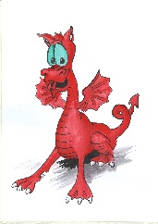

**Harvest Service**

On Thu 11th Oct our service of thanksgiving was held in the Church. The pupils

read some of their own poems and Jack wrote and sang his own song – very brave and impressive, da iawn ti! A collection was made for the 3 main army charities and we managed to raise over £80. Thankyou to Christine Williams

for stepping in at the last minute and for Ann Edwards for sorting out the collection and gift aid. There are a range of products in the school for pupils to purchase in aid of the poppy appeal – ranging from 50p to £1.

**Red, White & Blue day**

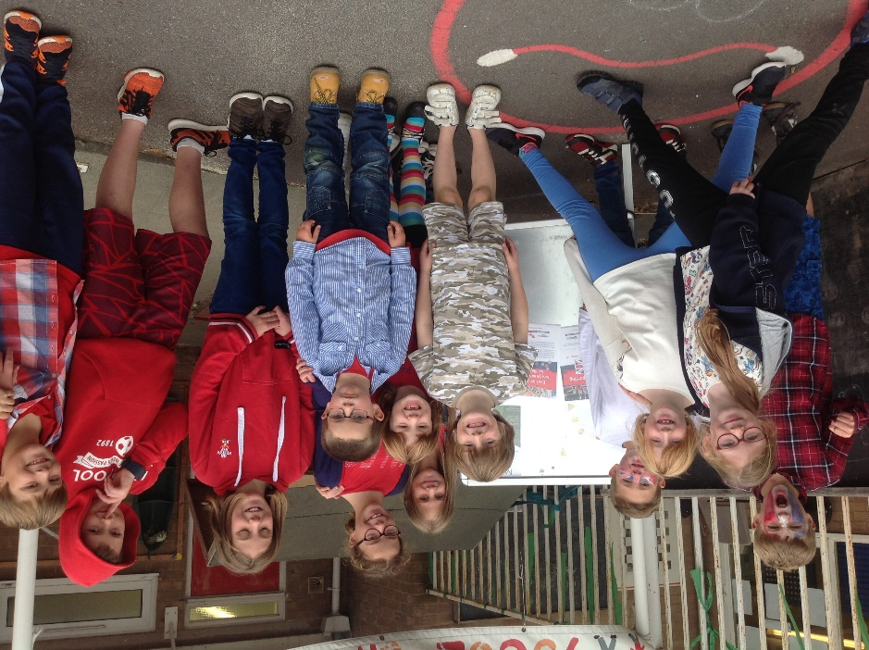

**Cycling Proficiency**

Year 6 pupils had their cycling proficiency training on Friday 5th Oct. They all did very well and the instructors commended them on their cycling skills. Da iawn chi.

**Transition**

Year 6 pupils had a visit from the Year 7 leader – Mr Rudge on Thu 11th Oct. They had the opportunity to ask him lots of questions and Mr Rudge explained about the exciting things that would be happening for them this year. They also attended the Open Evening at the high school, which was held on Thu 18th Oct.

**Bonfire theme menu – Mon 5th November**

Fire roasted bangers or vegetarian sausages, served with chips, baked beans or sweetcorn, followed by firecracker shortbread biscuit or fruit.

[bonfire PDF.pdf](bonfire%20PDF.pdf)

**Impact Schools**

Darren Mayor came to perform one of his exciting assemblies with the pupils on Thu 18th Oct.

The theme this time was ‘Light’.

|  |
| --- |
| **Dates for the diary:** Mon 5th Nov – Back to school  Wed 7th Nov - Bore Cymraeg  Sun 11th Nov – WW1 Commemorations in the village hall at 6pm  Tue 13th Nov – Urdd Swimming gala at the Flash  Fri 16th Nov – BBC Children in Need – wear yellow and/or spots for Pudsey! Wed 21st Nov – ‘Into Film’ club screening of ‘The Man who invented Christmas’, at Kino Kulture, Oswestry (Key Stage 2 pupils), packed lunch required.  Wed 28th Nov – whole school to Park Hall farm to see the WW1 trenches – packed lunch required. Fri 30th Nov – Own clothes day £1 Wed 12th Dec – Whole school to see Mother Goose Pantomime at Theatre Severn, Shrewsbury. Thu 13th Dec – Carols and Foundation Phase Nativity tableau in the Church at 6pm Fri 14th Dec – Christmas Jumper Day Fri 21st Dec – Break up from Christmas/Own clothes day £1 Mon 7th Jan 2018 – PD day  Tue 8th Jan 2018 – Back to school  C:\Users\User\Pictures\2018-10\IMG_0500.JPG  **Enjoy your half-term break – see you all on Monday 5th November!**  **Making the most of the mild October weather!** |
|  |
|  |
|  |
|  |